CSA5114-CRYPTOGRAPHY AND NETWORK SECURITY

LAB PROGRAMS

- Write a C program for Caesar cipher involves replacing each letter of the alphabet with the letter standing k places further down the alphabet, for k in the range 1 through 25.

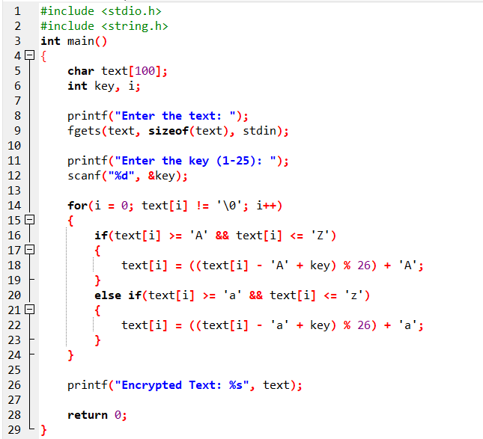

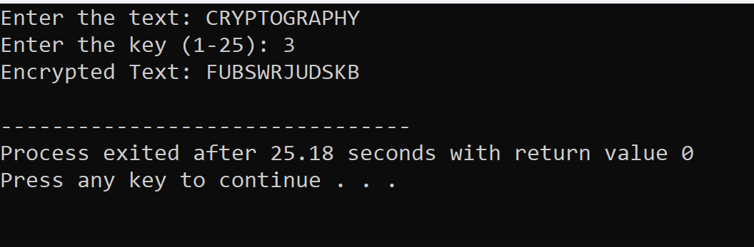

- Write a C program for monoalphabetic substitution cipher maps a plaintext alphabet to a ciphertext alphabet, so that each letter of the plaintext alphabet maps to a single unique letter of the ciphertext alphabet.

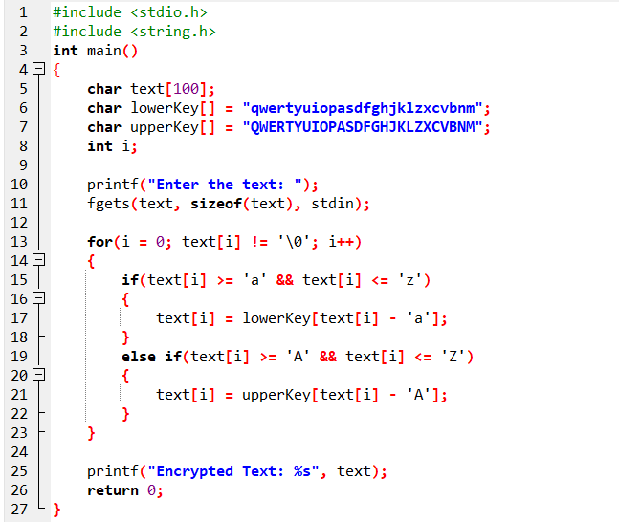

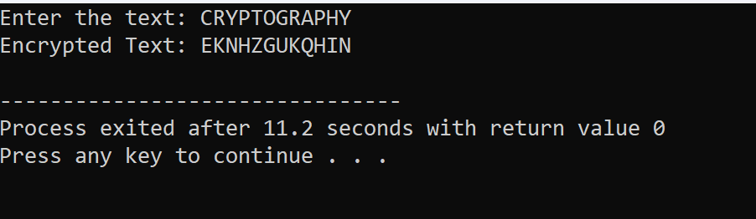

- Write a C program for Playfair algorithm is based on the use of a 5 X 5 matrix of letters constructed using a keyword. Plaintext is encrypted two letters at a time using this matrix.

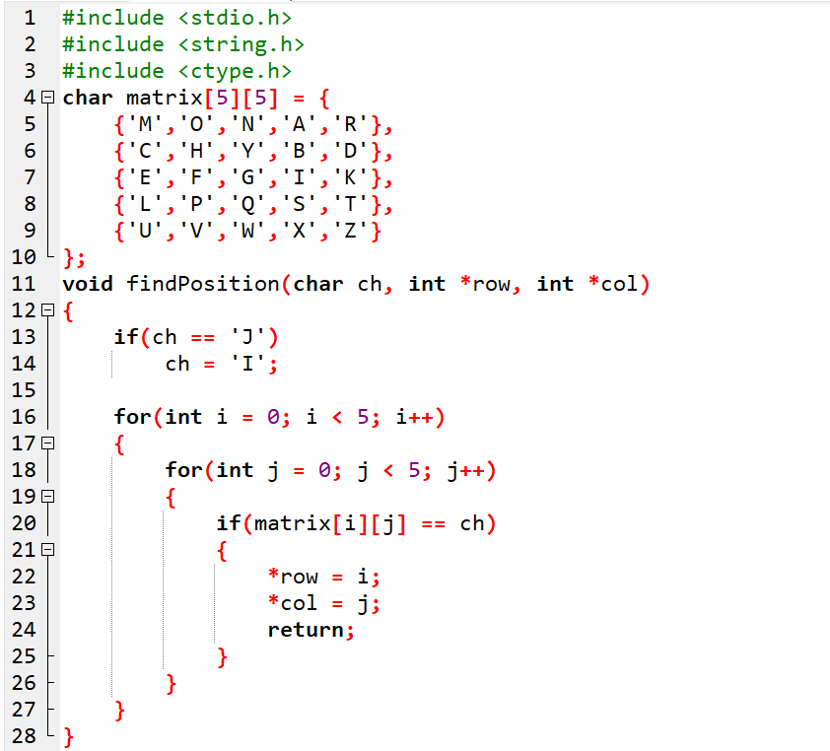
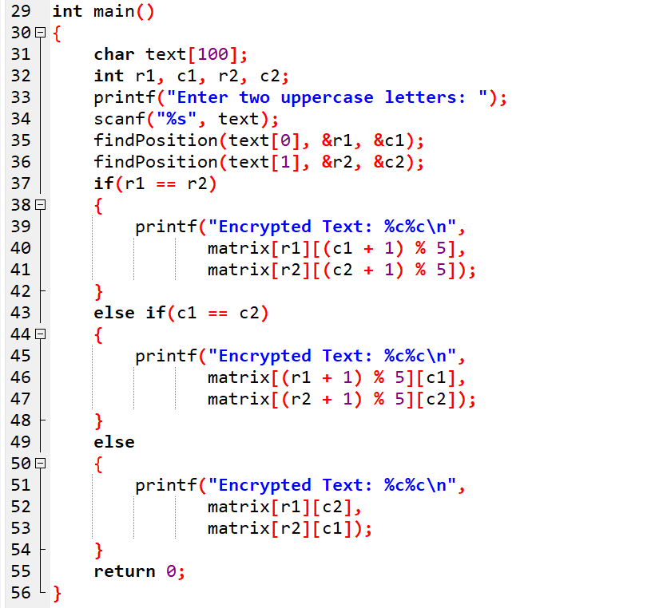

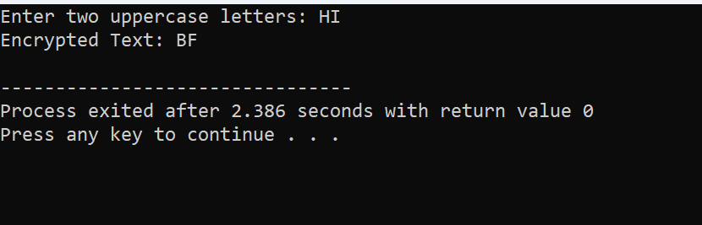

- Write a C program for polyalphabetic substitution cipher uses a separate monoalphabetic substitution cipher for each successive letter of plaintext, depending on a key.

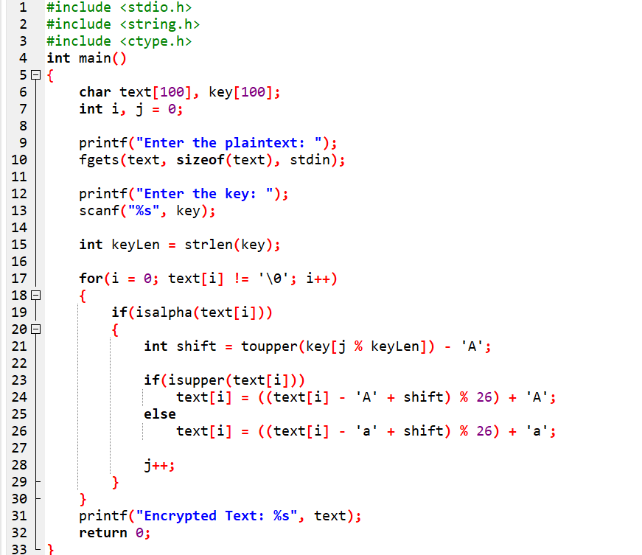

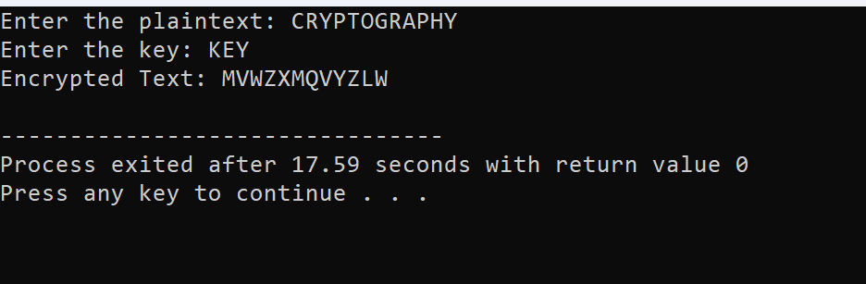
- Write a C program for generalization of the Caesar cipher, known as the affine Caesar cipher, has the following form: For each plaintext letter p, substitute the ciphertext letter C: C = E([a, b], p) = (ap + b) mod 26 A basic requirement of any encryption algorithm is that it be one-to-one. That is, if p q, then E(k, p) E(k, q). Otherwise, decryption is impossible, because more than one plaintext character maps into the same ciphertext character. The affine Caesar cipher is not one-to-one for all values of a. For example, for a = 2 and b = 3, then E([a, b], 0) = E([a, b], 13) = 3. a. Are there any limitations on the value of b? b. Determine which values of a are not allowed.

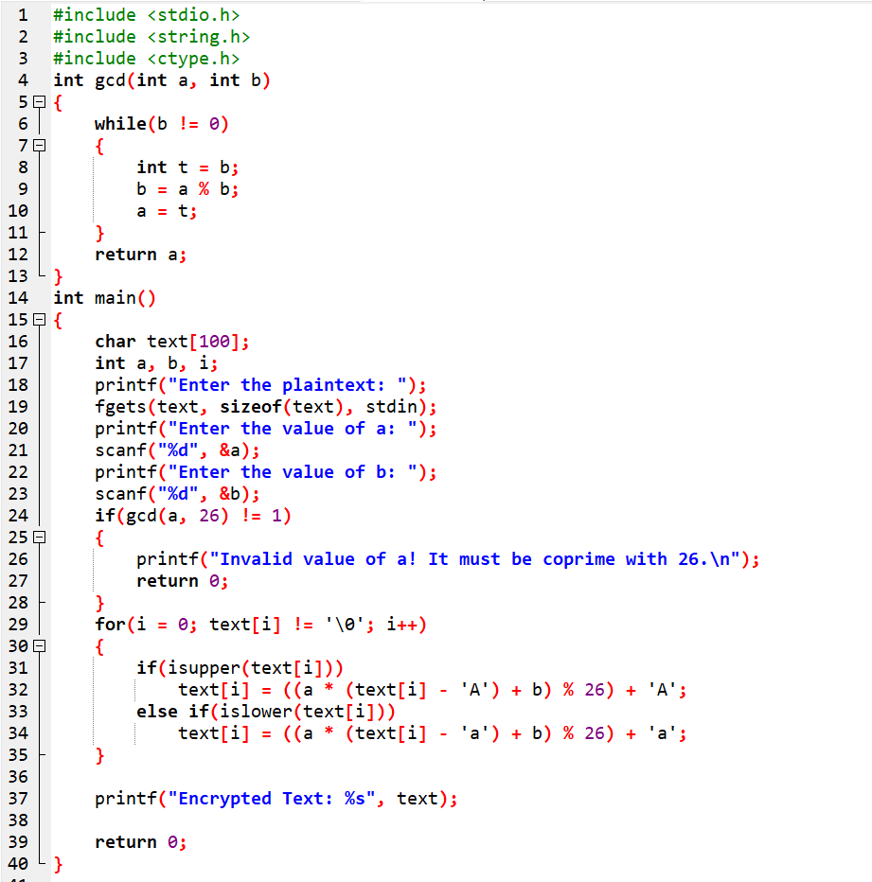

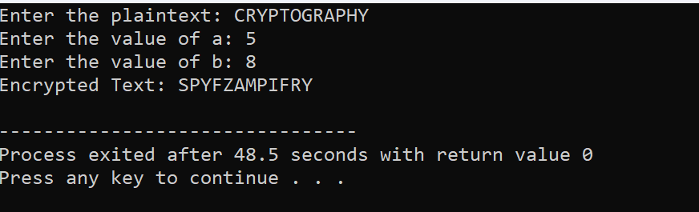

- Write a C program for ciphertext has been generated with an affine cipher. The most frequent letter of the ciphertext is “B,” and the second most frequent letter of the ciphertext is “U.” Break this code.

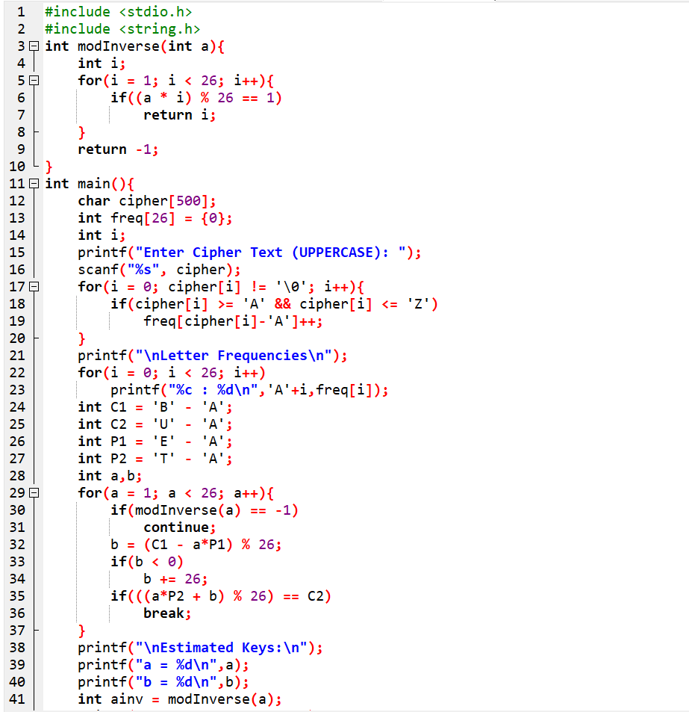
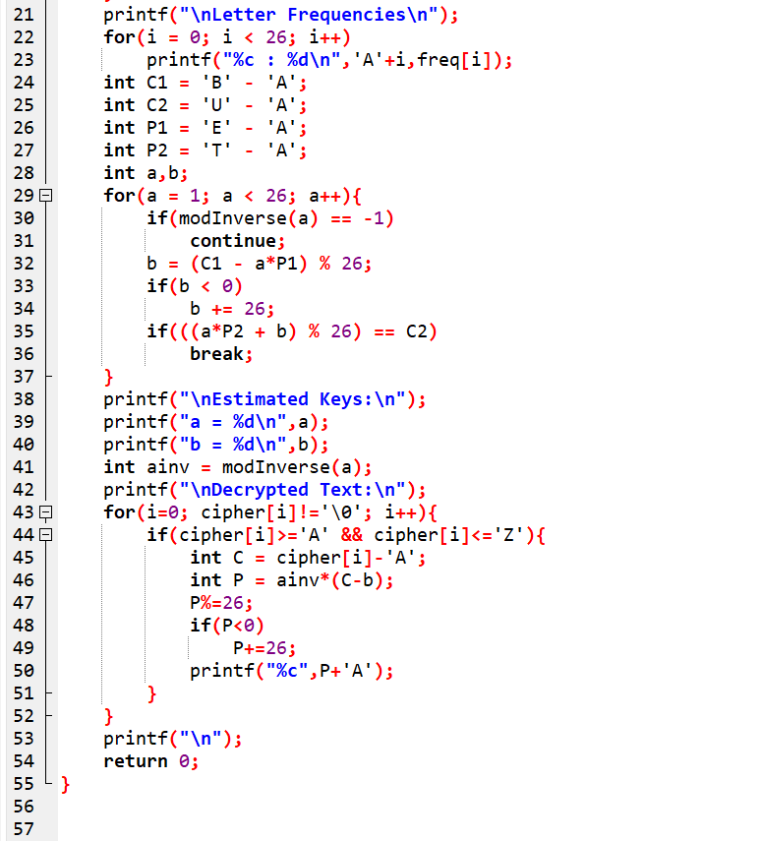
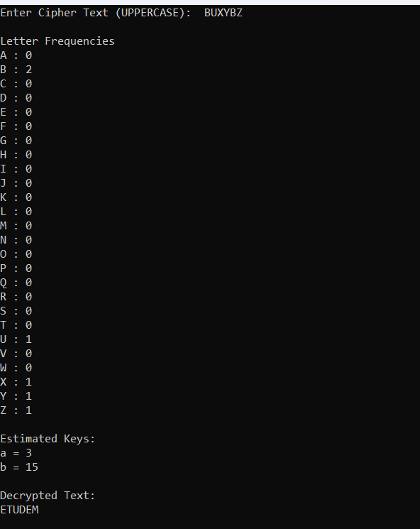

7. Write a C program for the following ciphertext was generated using a simple substitution algorithm.
53‡‡†305))6*;4826)4‡.)4‡);806*;48†8¶60))85;;]8*;:‡*8†83
(88)5*†;46(;88*96*?;8)*‡(;485);5*†2:*‡(;4956*2(5*—4)8¶8*
;4069285);)6†8)4‡‡;1(‡9;48081;8:8‡1;48†85;4)485†528806*81 (‡9;48;(88;4(‡?34;48)4‡;161;:188;‡?;

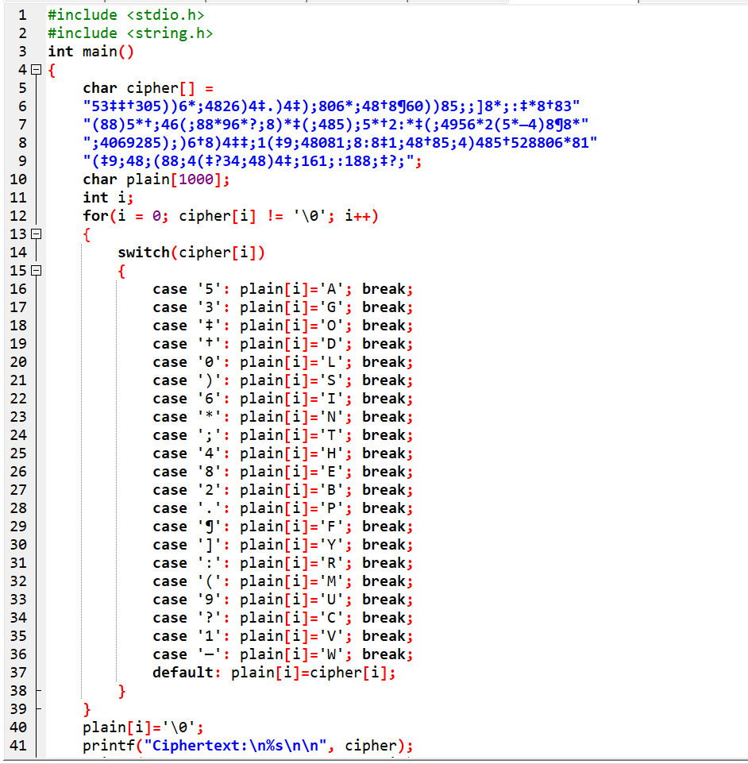
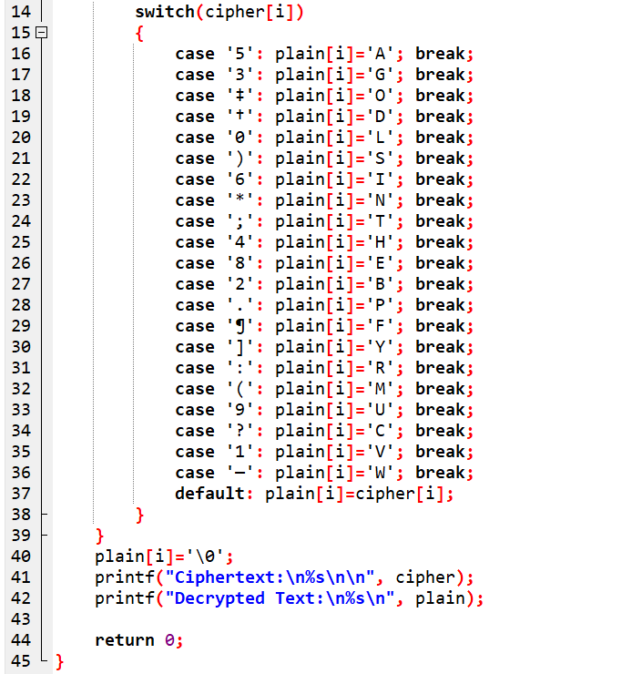

- Write a C program for monoalphabetic cipher is that both sender and receiver must commit the permuted cipher sequence to memory. A common technique for avoiding this is to use a keyword from which the cipher sequence can be generated.
For example, using the keyword CIPHER, write out the keyword followed by unused letters in normal order and match this against the plaintext letters: plain: a b c d e f g h i j k l m n o p q r s t u v w x y z cipher: C I P H E R A B D F G J K L M N O Q S T U V W X Y Z

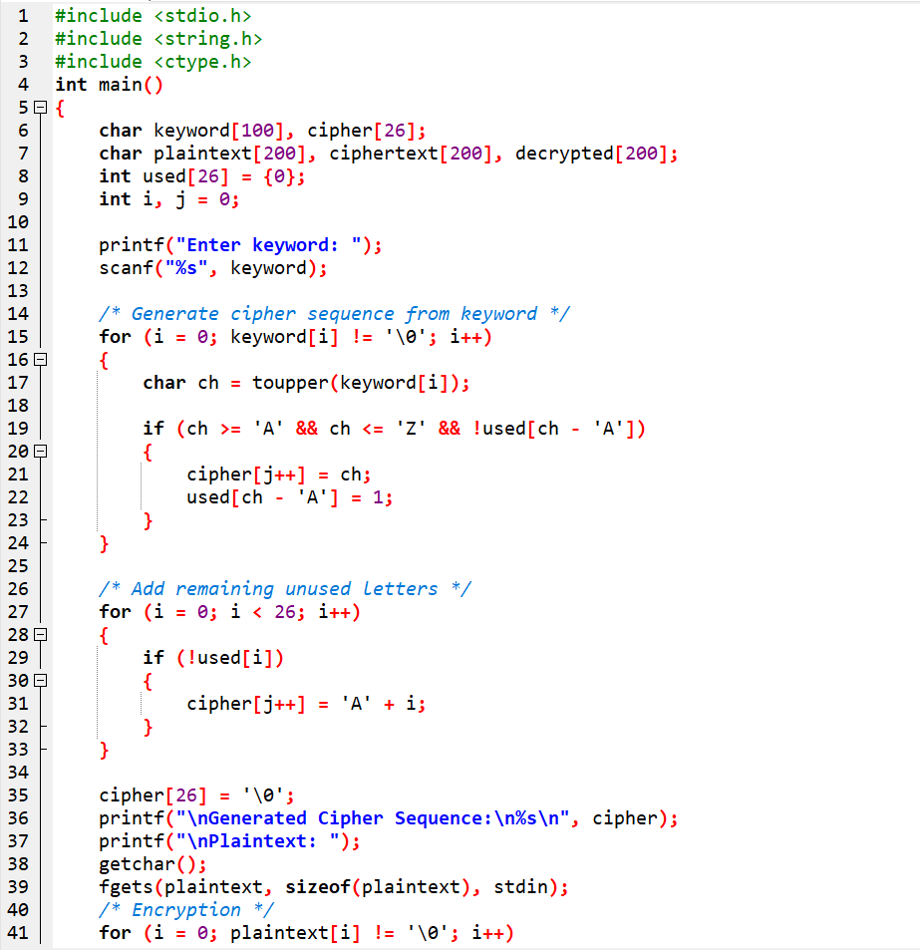
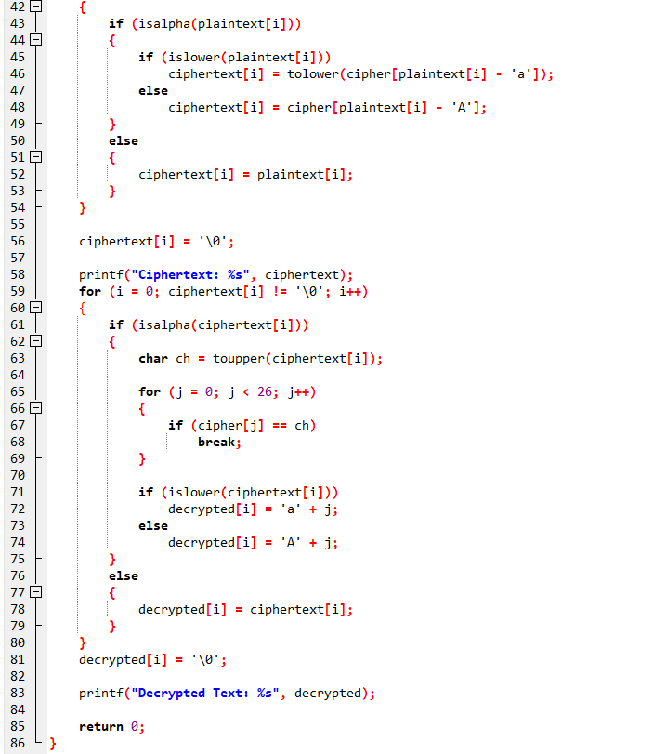

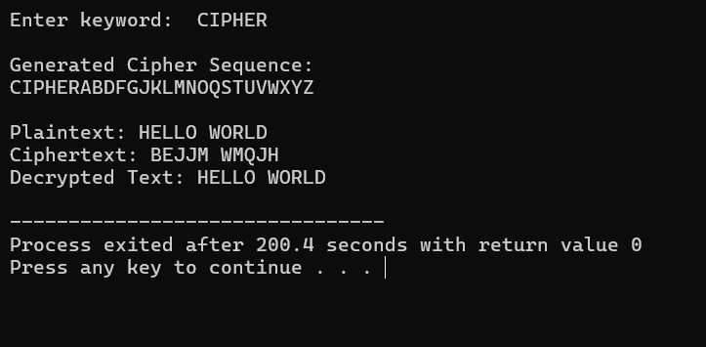

9. Write a C program for PT-109 American patrol boat, under the command of Lieutenant John F. Kennedy, was sunk by a Japanese destroyer, a message was received at an Australian wireless station in Playfair code:
KXJEY UREBE ZWEHE WRYTU HEYFS
KREHE GOYFI WTTTU OLKSY CAJPO
BOTEI ZONTX BYBNT GONEY CUZWR
GDSON SXBOU YWRHE BAAHY USEDQ

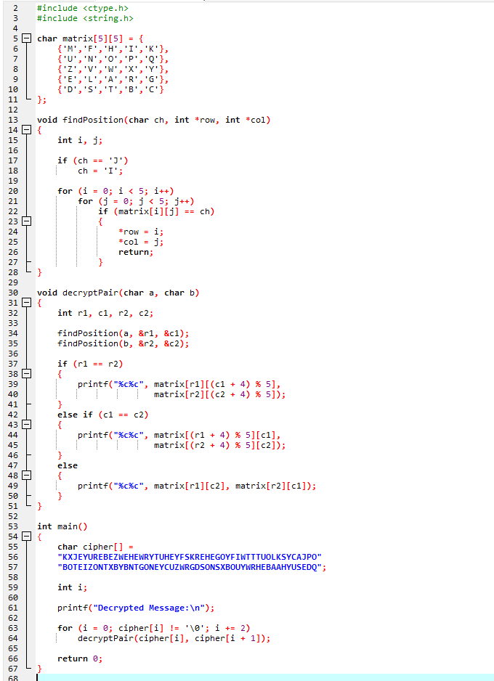

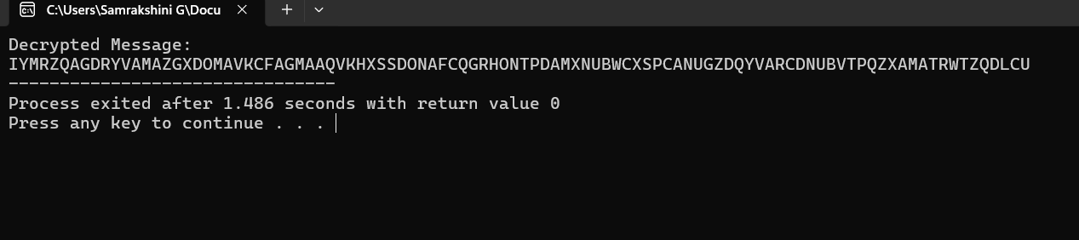

10. Write a C program for Playfair matrix:
M F H I/J K
U N O P Q
Z V W X Y
E L A R G
D S T B C
Encrypt this message: Must see you over Cadogan West. Coming at once.
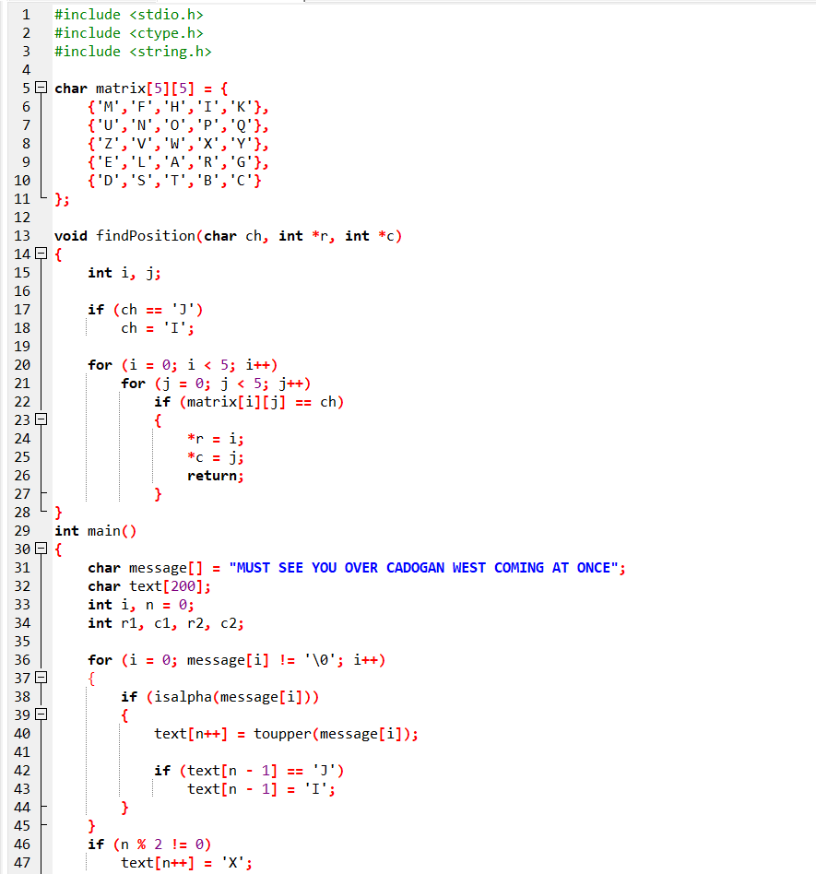

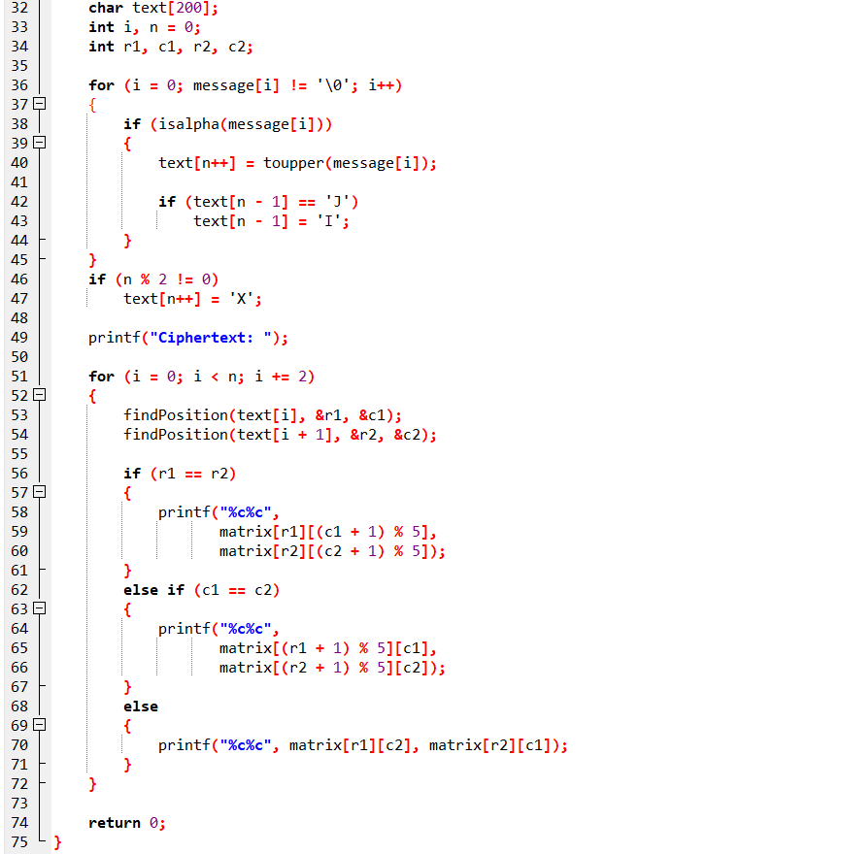
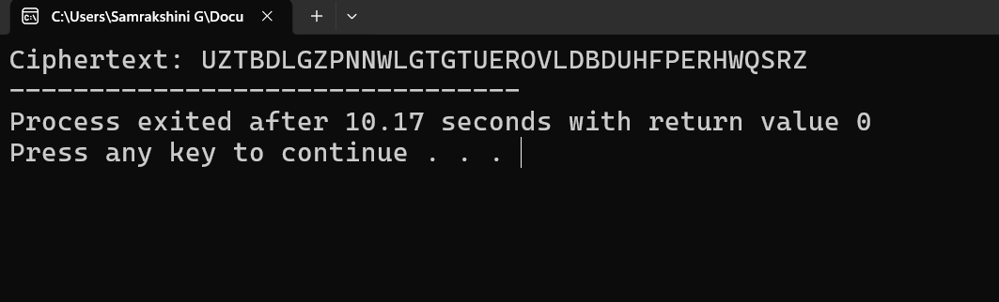

11. Write a C program for possible keys does the Playfair cipher have? Ignore the fact that some keys
might produce identical encryption results. Express your answer as an approximate power of 2.
a. Now take into account the fact that some Playfair keys produce the same encryption results. How
many effectively unique keys does the Playfair cipher have?

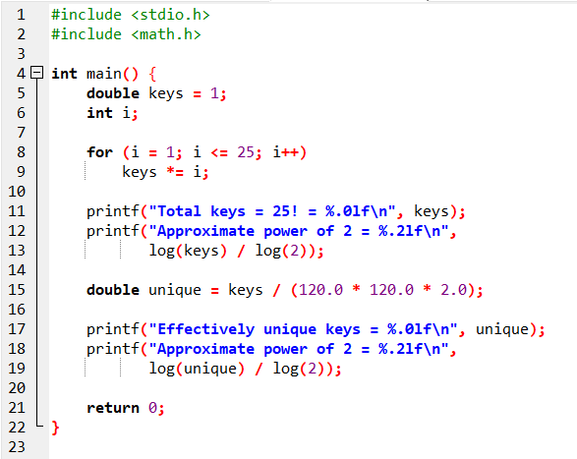

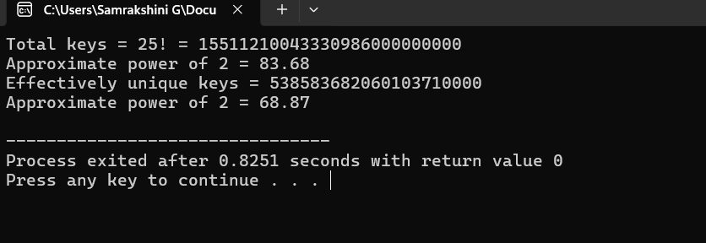

12. a. Write a C program to Encrypt the message “meet me at the usual place at ten rather than eight
oclock” using the Hill cipher with the key.
9 4
5 7
a. Show your calculations and the result.
b. Show the calculations for the corresponding decryption of the ciphertext to recover the original plaintext.

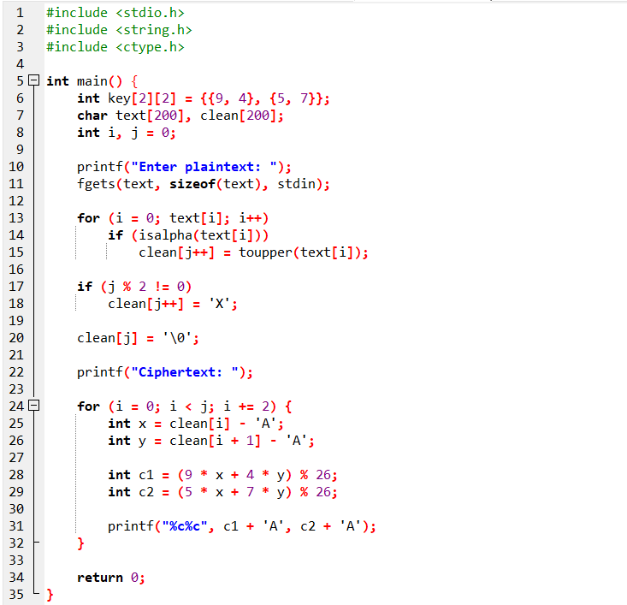
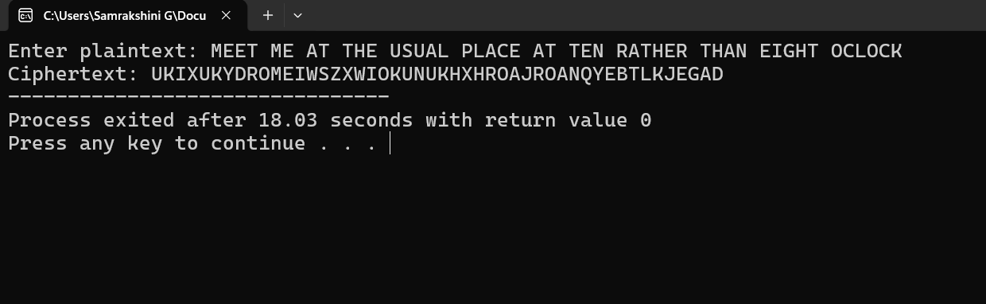

13. Write a C program for Hill cipher succumbs to a known plaintext attack if sufficient plaintext– ciphertext pairs are provided. It is even easier to solve the Hill cipher if a chosen plaintext attack can be mounted.

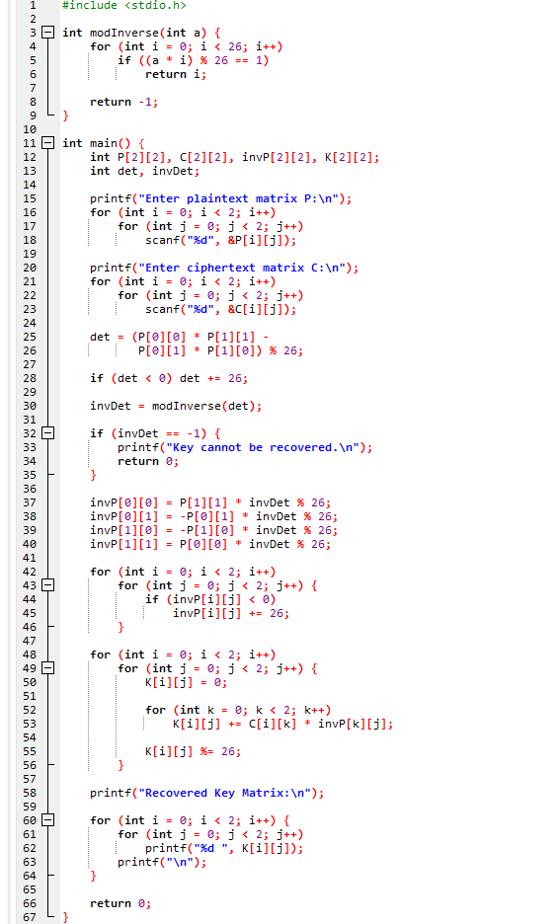

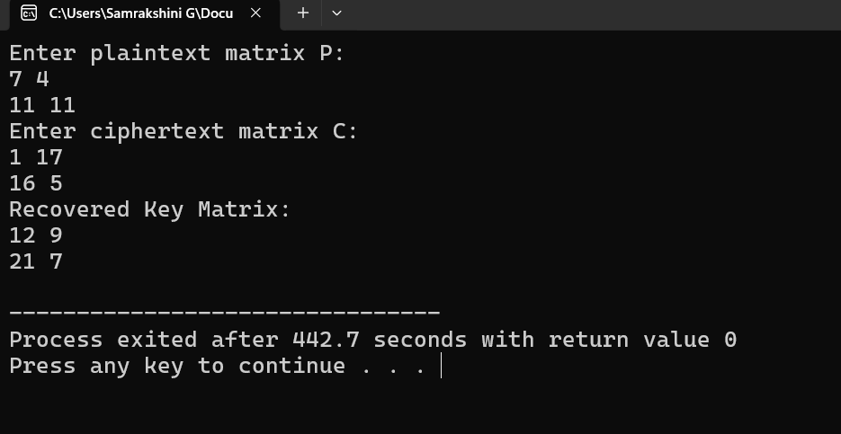

14. Write a C program for one-time pad version of the Vigenère cipher. In this scheme, the key is a stream of random numbers between 0 and 26. For example, if the key is 3 19 5 then the first letter of plaintext is encrypted with a shift of 3 letters, the second with a shift of 19 letters, the third with a shift of 5 letters, and so on
a. Encrypt the plaintext send more money with the key stream: 9 0 1 7 23 15 21 14 11 11 2 8 9
b. Using the ciphertext produced in part (a), find a key so that the cipher text decrypts to the plaintext cash not needed.
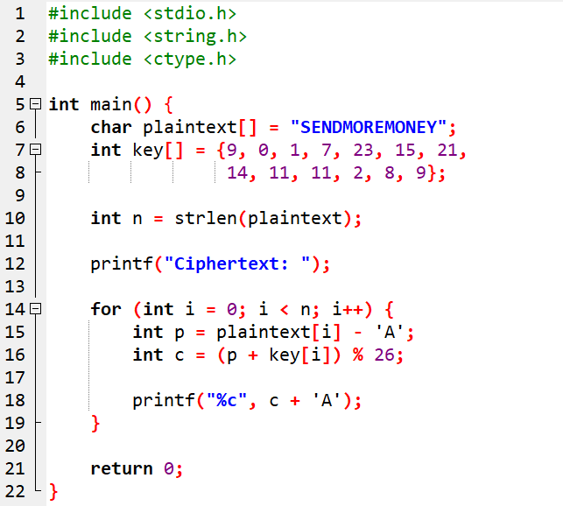

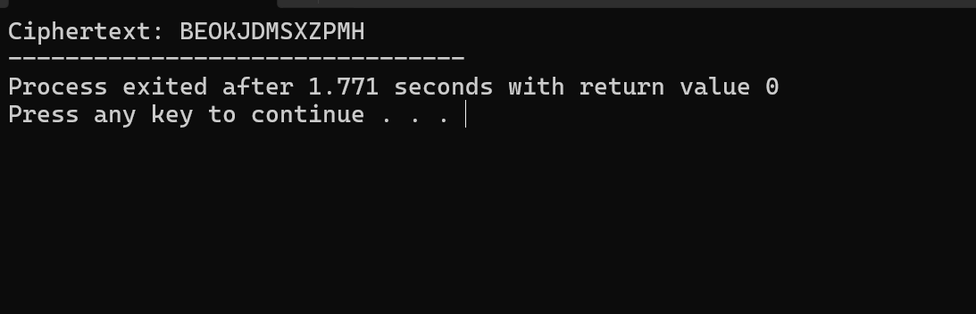

15. Write a C program that can perform a letter frequency attack on an additive cipher without human intervention. Your software should produce possible plaintexts in rough order of likelihood. It would be good if your user interface allowed the user to specify “give me the top 10 possible plaintexts.”
